**Success is Inevitable**

**Action Guide**

Thanks again for purchasing my book. I really want you to succeed and to get as much as you can from it. Please make sure you use this action guide alongside the book. In the end, your commitment is what will determine how much you get out of this book. I encourage you to print out this workbook to make it easier to refer to it as you are reading the book. Also, writing down your answers using a pen is more powerful than just typing on your computer.

Let’s get started!

**PART I. Mastering the Four Powers That Enable Success**

**Defining success**

What does success really mean to you? Write down your personal definition of success below:

**I. The Power of Absolute Responsibility**

If you were to take one hundred percent responsibility of your life, what is one thing you would start doing today to improve your life?

Write down your answer below:

**II. The Power of Belief**

You can dramatically increase your level of confidence by building self-discipline, boosting your self-esteem and enhancing your self-confidence

***The Self-Empowerment Triangle***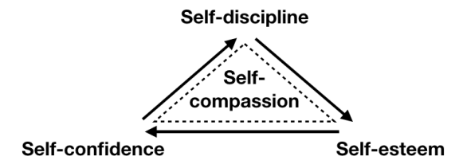

**Building self-discipline**

To build self-discipline consistency is key. Write down one thing you could start doing consistently every day for the next thirty day (meditating, practicing gratitude, setting goals etc.)

-

**Boosting your self-esteem**

Do at least one of the following exercises:

1. Ask yourself 3 things you want to acknowledge yourself for (for at least a week)
2. Write down all your accomplishments (at least once)
3. Reward yourself (select a reward for one of your goals)
4. Record every positive thing you’ve ever been said. (for at least a month)

**Enhancing your self-confidence**

Remain consistent with your new daily habit and keep acknowledging your small wins. Re-read the book and apply each law to the best of your ability.

**III. The Power of Clarity**

Rate yourself on a scale of 1 to 10 for the following, 1 being a big NO and 10 a big YES:

**Career/mission**: do you wake up excited? Dod you feel like you’re making a difference in your own unique way?

|  |
| --- |
| 1 10 |

**Family**: do you spend enough quality time with your family?

|  |
| --- |
| 1 10 |

**Finance:** do you make the kind of money you want to make or do you struggle to make ends meet?

|  |
| --- |
| 1 10 |

**Health** (Physical and emotional): Do you have a healthy body? How about your emotional well being?

|  |
| --- |
| 1 10 |

**Personal growth:** do you feel like you’re growing into the person you want to become?

|  |
| --- |
| 1 10 |

**Relationship**: Is your relationship with your partner the best it could be?

|  |
| --- |
| 1 10 |

**Spirituality**: do you feel a sense of connection with God/the universe?

|  |
| --- |
| 1 10 |

For each area, take a few minutes to visualize in details what your ideal vision looks like. See yourself as being already at a 10 in each area and answer the question below:

* **Career:** What contribution are you making to society and the world in general? What does your day at work look like?
* **Family:** How are you interacting with your family on a day-to-day basis and how does that make you feel?
* **Finance:** How much money are you earning each month? What are you doing with this money?
* **Health:** How do you feel every day? What does your diet look like?
* **Personal growth:** What three words best describe you? What do people say about you when you’re not there? What message are you spreading to the world?
* **Relationship:** What emotions are you experiencing daily? How do you treat your partner? And how does him or her feel as a result of that? How does your partner treat you?
* **Spirituality**: How do you serve God or the universe? What spiritual qualities do you embody?

**Your vision for your life**

Write a short statement for each area of your life describing your ideal vision. For now, make sure you write at least one statement.

**Career:**

**Family:**

**Finance:**

**Health:**

**Personal growth:**

**Relationship:**

**Spirituality:**

**The importance of self-awareness**

Rate yourself for each statement below, 1 being false, 10 being true.

I know my core values and live by them

|  |
| --- |
| 1 10 |

I know my weaknesses and cope with them effectively

|  |
| --- |
| 1 10 |

I understand my core beliefs and how they affect my behaviors and actions

|  |
| --- |
| 1 10 |

I’ve identified thought patterns that prevent me from reaching my potential

|  |
| --- |
| 1 10 |

I’ve identified my zone of genius

|  |
| --- |
| 1 10 |

I know whether I’m an extrovert or introvert and use it to my advantage

|  |
| --- |
| 1 10 |

I control my emotions

|  |
| --- |
| 1 10 |

I know my blind spots and seek new perspectives whenever necessary

|  |
| --- |
| 1 10 |

I listen to my intuition

|  |
| --- |
| 1 10 |

Now, look at your score for each statement and ask yourself, “What are the two things that, if I were to work on would make the biggest difference in my life?”. Resolve to work on these two things using the exercises mentioned in the book.

**2. Setting crystal clear goals**

Select one major goal you want to achieve. (The one that would make the biggest difference in your life right now). Make it SMART and break it down into monthly, weekly and daily goals

For your reference SMART goals are:

* **Specific:** What exactly do you want? What are you trying to achieve?
* **Measurable**: Can you assess the progress towards your goal easily? How will you know whether you’ve achieved it?
* **Achievable**: Is it achievable? Is the timeframe realistic? Can you put in the effort required despite other responsibilities?
* **Relevant:** Is it in line with your values? Is it exciting you?
* **Time-bound:** Do you have a clear deadline for your goals?

For more on how to set goals, you can also check out my book [Goal Setting: The Ultimate Guide to Achieving Goals that Truly Excite You.](http://myBook.to/goalsetting)

Your SMART goals:

**IV. The Power of Passion**

**Uncovering your passion**

To help you clarify your passion, answer the following questions:

1. What did you enjoy doing when you were a kid?

2. Who do you envy? What are the people you envy doing?

3. If all your family members, friends and people you know were no longer around and you were all alone, what would you start doing from today?

4. If you had all the time and money in the world, what would you do?

5. If you had complete confidence and were already your absolute best self, what would you be doing with your life?

6. How do you want to express yourself to the world? Do you want to entertain, educate, inspire, heal, teach, or create? What emotions do you want people to feel as a result of the work you’re doing?

For more on how to find your passion refer to [The Passion Manifesto: Escape the Rat Race, Uncover Your Passion, and Design a Career and Life You Love](http://mybook.to/passion_manifesto)

**2. Strengthening your whys**

Write down all the reasons why you *must* achieve your goal. To help you do so, you can use the four motivators: pain, pleasure, ego and love (You can write them in brackets after each of your reasons)

-

-

-

-

-

-

-

-

-

-

-

-

-

-

-

-

-

-

**PART II. Activating the Power of Commitment**

Rate yourself on a scale of 1 to 10, 1 being false, 10 being true.

I’m willing to learn whatever I need to learn to get where I want to be

|  |
| --- |
| 1 10 |

I refuse to give up until I get the results I want

|  |
| --- |
| 1 10 |

I constantly seek to raise my standards

|  |
| --- |
| 1 10 |

I’m willing to swallow pride and use feedback to improve

|  |
| --- |
| 1 10 |

What could you do to further commit to your goal? Write down at least one thing that could help you strengthen your commitment:

Remember, believing in yourself (power of belief), knowing what you want (power of clarity) and having a strong why (power of passion) will make it easier for you to commit. If you struggle to commit, look how well you fair for each of them.

**Part III. Mastering the Laws of Success**

**I. The Law of Humility**

*By swallowing your pride and accepting to change everything needed to achieve your goals, you will dramatically increase the odds you succeed.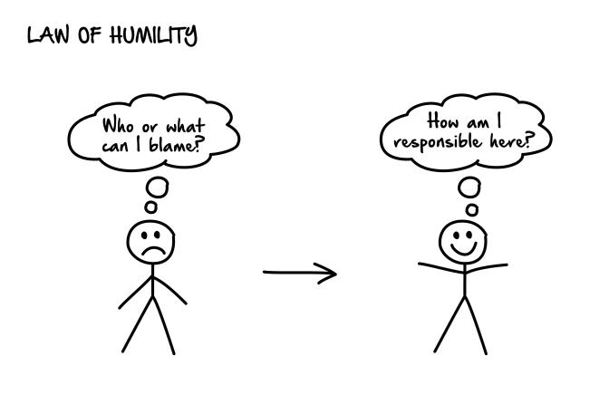*

Write at least one reason pride could stand in your way. Answering the following questions might help you: How could pride prevent you from achieving the results you want in life? Do you refuse to ask for help? Are you unwilling to change things that don’t work?

Your answer:

**II. The Law of Mastery**

*If you apply anything you learn and go as deep as you can, you will inevitably get resu lts long-term.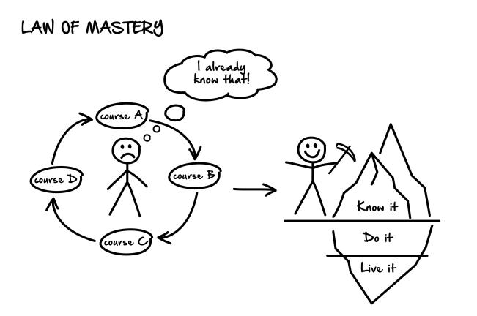*

**Developing a mastery mentality**

On a scale of 1 to 10, 1 being false 10 being true, evaluate yourself on the following points:

I easily avoid jumping from one opportunity to another.

|  |
| --- |
| 1 10 |

I put into practice everything I read or learn about.

|  |
| --- |
| 1 10 |

When I learn something new I keep practicing until I reach a high level of mastery.

|  |
| --- |
| 1 10 |

Look at one area of your life in which you aren’t satisfied. How much of what you know have you actually put into practice? Have you mastered the fundamentals in this area?

**1. Focusing on one thing at a time**

Look at all the projects and goals you’re working on right now. Now, select the one you’re the most excited about and write it down. Turn it into a SMART goal and spend most your effort on it in the next few weeks or months *until* you get the results you want.

Your most exciting project:

Your SMART goal:

**2. Practicing what you know intellectually**

Write down all the things you know at an intellectual level but haven’t truly mastered. That is, things you read or heard about but haven’t really applied in your life.

-

-

-

-

-

-

-

-

-

-

**3. Repeating the process until you reach a high level of mastery**

Answer the following question: What one thing if you were to focus on until you master it, would make the biggest impact on your life?

**III. The Law of Focus**

*Monomaniacal focus on the most important area of your life right now will yield great results while positively impacting most of the other areas of your life.*

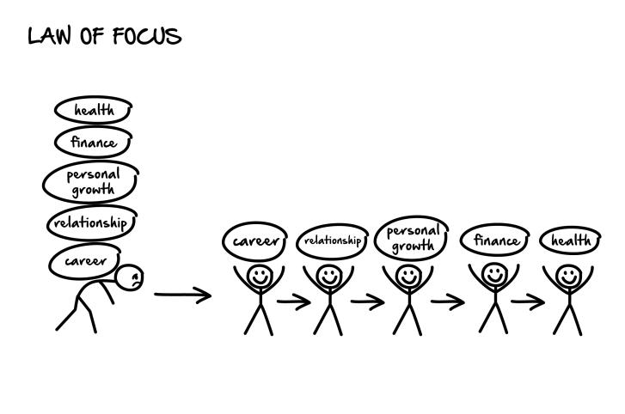

Among the five areas—health, finance, relationships, career, personal growth—which area, if you were to focus most of your effort right now, would help most transform your life?

**IV. The Law of Effective Actions**

*Success becomes almost inevitable when you identify key actions and focus on them daily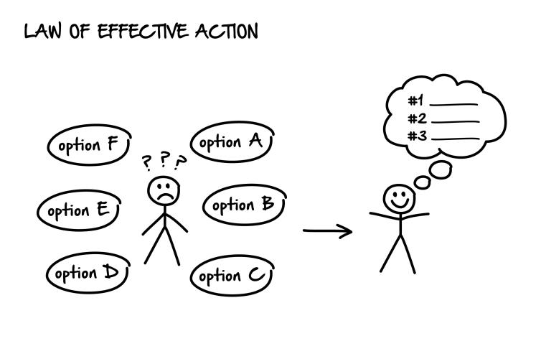*

Write down below what you could do to identify the strategic moves you need to adopt to achieve your goal. (Examples: find a role model, interview someone who has already achieved your goals etc.)

-

-

-

-

-

-

-

-

-

-

Brainstorm strategic move ideas.

Come up with at least 20 things you could do to achieve your goal:

-

-

-

-

-

-

-

-

-

-

-

-

-

-

-

-

-

-

-

-

**Identify your strategic moves**

What are three to five strategic moves that, if you were to focus most of your time and effort on would allow you to achieve your biggest goal?

**Apply the 80/20 rule**

Use the 80/20 rule in one or several of the areas below:

**Relationships:** What are the few people who bring you most of your joy? How could you spend more time with them?

-

-

-

-

**Happiness**: What are the few things you derive most of your happiness from? What could you do to make them your main point of focus?

-

-

-

-

**Work:** What are the few tasks that really move the needle? How could you make them your priority?

-

-

-

-

**Thoughts:** What are the few thoughts that generate the most of your joy and excitement? What practice would allow you to consciously focus on these thoughts more often?

-

-

-

-

**Worries:** What are the few things you worry about that generate most of the stress you experience in your life? How you could eliminate these worries from your life?

-

-

-

-

**V. The Law of Deliberate Practice**

*You’ll become far more competent at what you do if you design effective practices aligned with your goals.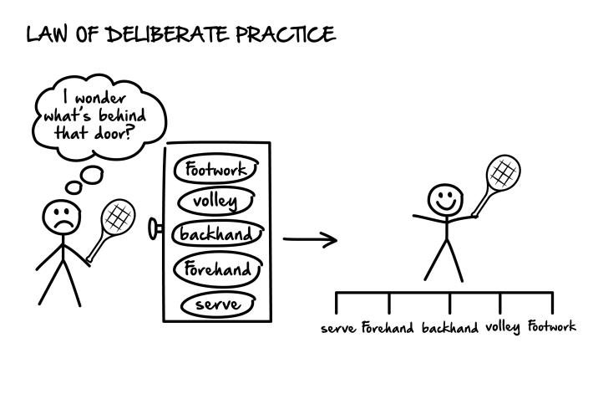*

Apply deliberate practice to one of your goals by answering the questions below:

* Can you acquire the skills you need using effective training techniques that already exist? Y / N
* Does your current practice take place outside of your comfort zone? Y / N
* Does your current involve specific, well-defined goals? Y / N
* Does your current practice requires your full attention and conscious actions? Y / N
* Do you regularly ask for feedback? Y / N
* Does your current practice allow you to create and rely on effective mental representation? Y / N
* Does your current practice involves working on existing skills or building new ones by focusing on some aspects of those skills that need to be improved? Y / N

Based on your answers to the previous questions, write down what you could do specifically to improve the way you work on your goal:

**VI. The Law of Consistency**

*Simple daily habits repeated for a few years lead to exceptional results, often far better than you would get by brute-forcing your way to success.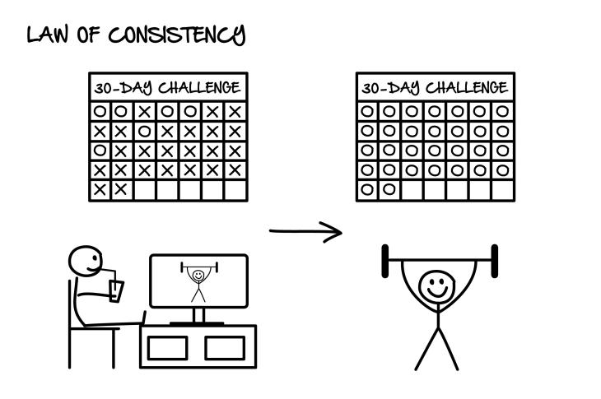*

**Turning strategic moves into daily habits**

Look at the 3-5 strategic moves you’ve identified previously. Now, what could you do to turn them into daily habits?

Your daily habits:

**Adoption one daily habit**

Select one thing you could do first thing in the morning to help you achieve your main goals. Stick to it for at least thirty days.

Your daily habit:

**VII. The Law of Identification**

*The more you think, feel and act like the person you wish to become, the faster you’ll achieve your goals.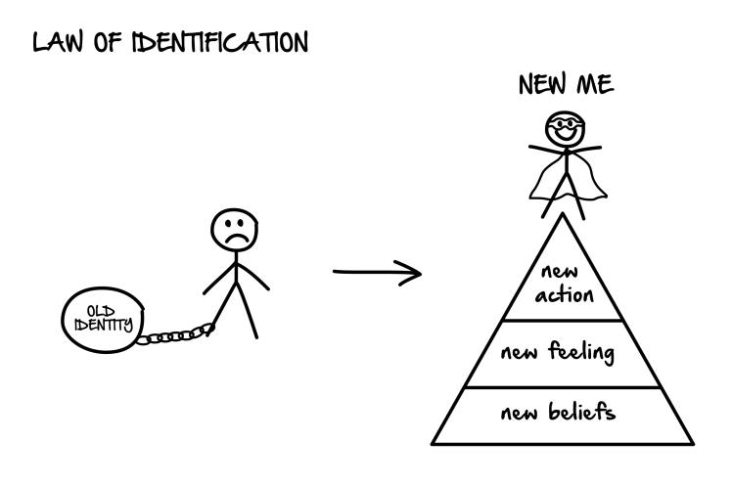*

Write down below the side effects of having already achieved your goals:

1. What would be your core beliefs about yourself and about the world?

-

-

-

2. How would you think differently?

-

-

-

3. How would you feel?

-

-

-

4. What would you do differently?

-

-

-

5. What new habits would you have?

-

-

-

6. What old habits would you have rejected?

-

-

-

**VIII. The Law of Conditioning**

*You can train yourself to experience any emotion if you focus on feeling that particular emotions for long enough.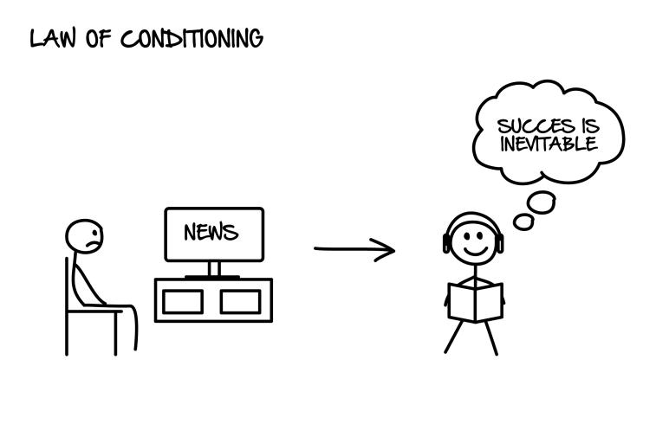*

Select one daily habit that will help you condition your mind to experience more positive emotions in your life. If you can, make it part of your morning ritual by combining it with the thing you committed to doing in the section *Law of Consistency*.

Your daily habit:

**IX. The Law of Attraction**

*The more you focus on something, the more likely you are to attract that thing in your life.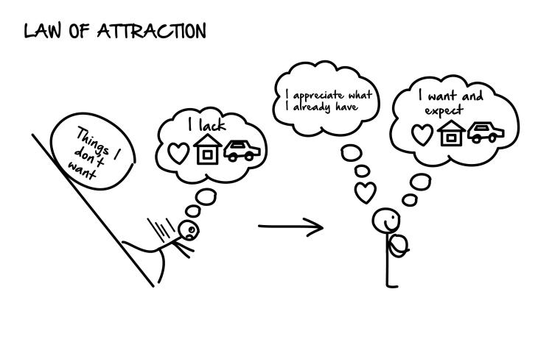*

Throughout your day, spend as much time as possible focusing on the main area you wish to make a change in. You can also repeat affirmations, visualize the results you want, write it down on a paper you put on your desk etc.

Write down below what you will stop focusing on (for instance: lack of money, past failures etc.). Then, cross out each element in your list.

-

-

-

-

-

-

-

-

-

Write down below the things you want to spend most of your time focusing on (what your grateful for, goals you want to achieve etc.). Underline each element in your list.

-

-

-

-

-

-

-

-

-

-

-

**X. The Law of Reset**

*Every day is a new day independent of the previous one.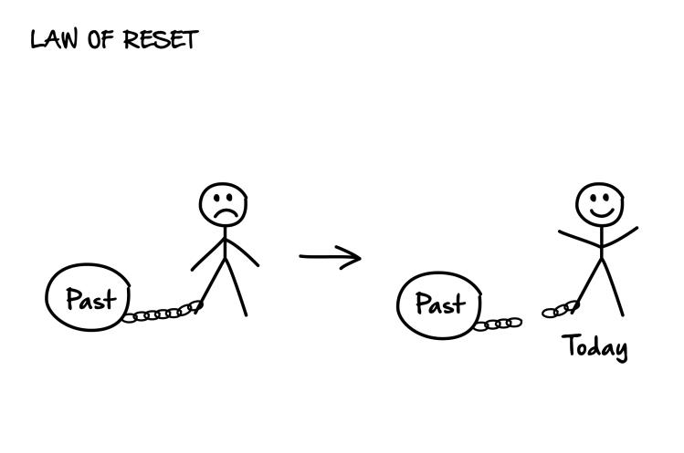*

Do at least one of the following exercises:

1. Brainstorming exercise:

Write down everything you could do differently. Could you do something different upon waking up? Adopt one new positive habit in your life? Contact someone you haven’t contacted for a while? Start journaling?

-

-

-

-

-

-

-

2. 7-Day Challenge:

For the next seven days, begin your day as though you have been born again, and feel the field of possibilities ahead of you.

3. Visualization exercise:

Forget about everything—who you think you are, your past, your future etc.—and reconnect with the present moment. You can close your eyes to do this exercise. Now, spend a couple of minutes envisioning your future and what you want to create.

**XI. The Law of Intent**

*The more purposeful you are during your day, the better results you will achieve.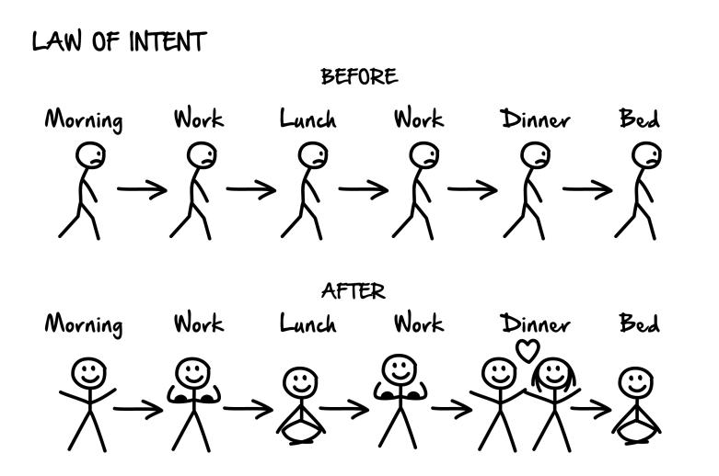*

Think of your typical day. What is the one segment of your day that if you could bring a specific intent to, would have the most positive impact? For the next seven days, resolve to set your desired intent before moving to that specific segment of your day.

Write down below the one segment of your day you want to change and how you want to feel during that time of the day.

Your segment of the day:

How you want to feel:

**XII. The Law of Continuous Learning**

*Getting better is inevitable if you keep acquiring new skills and learn from failures. As you improve, long-term success becomes highly probable.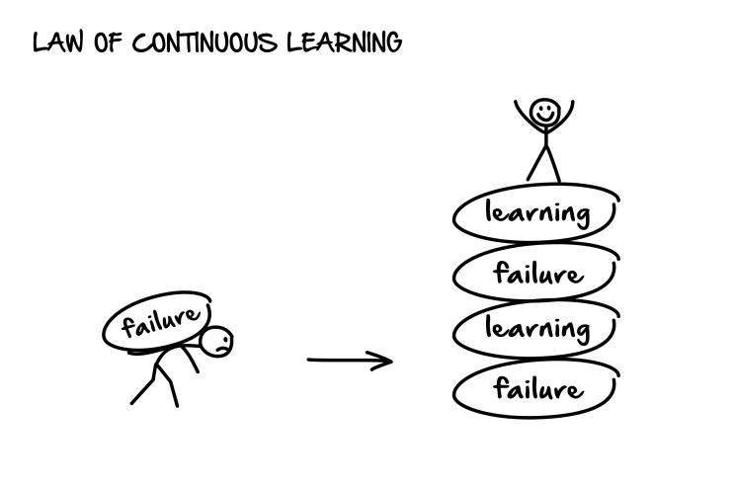*

Commit to learning. Dedicate at least ten minutes daily to reading educational material that will help you achieve your long-term vision

**XIII. The Law of Perseverance**

*You can and will achieve far more than you can ever begin to imagine if you keep persevering and refuse to give up prematurely.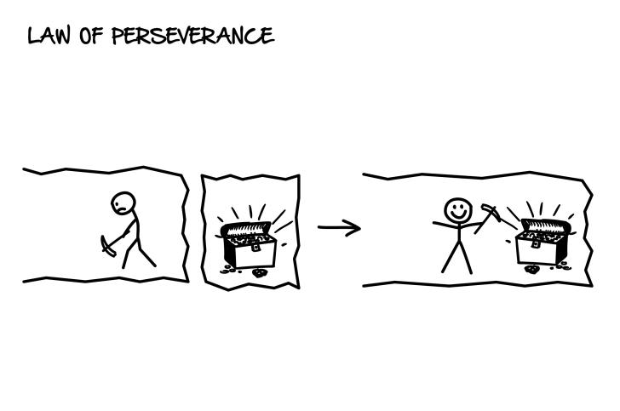*

Implement a Bullet-Proof Timeframe for your goal and commit to never giving up until you reach the deadline you chose.

*Example: I’ll keep writing books until April 18th, 2020.*

Your Bullet-Proof Timeframe:

What you commit to doing by then:

**XIV. The Law of Courage**

*The more often you can face your fear and move beyond your comfort zone, the more you’ll achieve in life.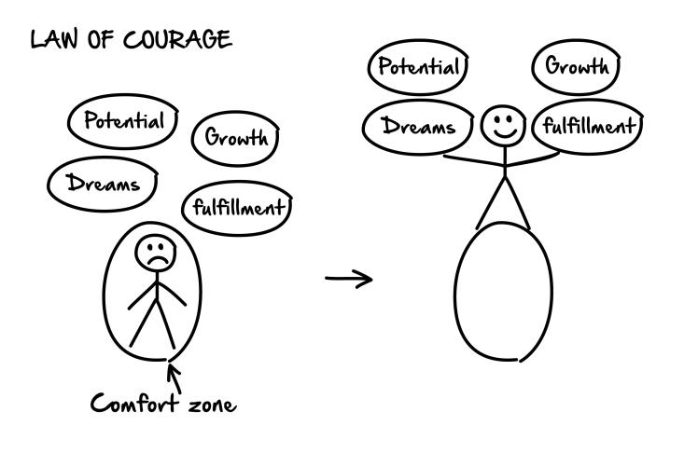*

What is one thing you’ve been wanted to do for a while, but put off because of fear?

Could you challenge yourself and do that thing this week? Write down below one thing you could do to move beyond your comfort zone.

**XV. The Law of Flexibility**

*The more you are willing to consider all the options available to achieve your goal, the more likely you are to succeed.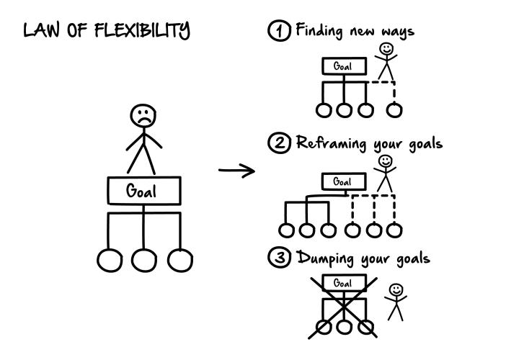*

How could you use the Law of Flexibility to increase the chances that you achieve your long-term goals? Remember that you can identify additional ways to achieve your goals, reframe your goals or give up on your goals.

What are different ways you could achieve your goals?

-

-

-

-

How could you reframe your goal so that it opens the doors to new possibilities?

Does your goal still excite you or should you give up on it?

**XVI. The Law of Patience**

*You must trust the process and remain consistent until you see the fruits of your labor.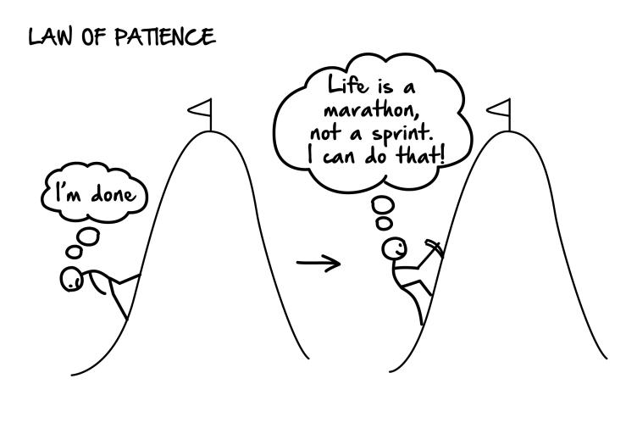*

Remember a specific time in the past when you gave up prematurely on a goal. Imagine how things could have been different if you had used the *Law of Patience.*

The one time I gave up prematurely:

**XVII. The Law of Long-Term Thinking**

*As you develop the habits of long-term thinking, you’ll become far more successful in all areas of your life.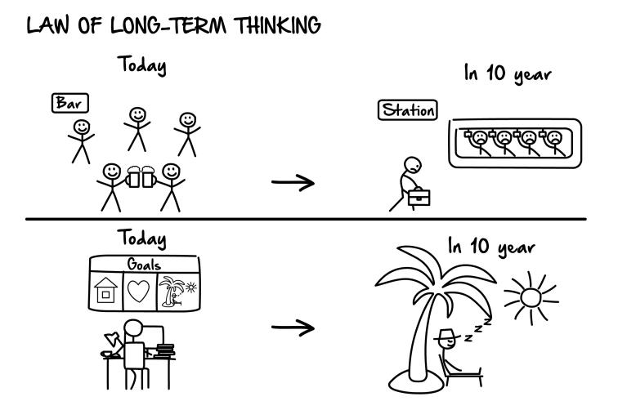*

Write down your answers to the following questions:

Is what you are doing today or this week, will allow you to achieve my long-term goals?

What are you thinking about throughout your day? Make a list of some of the recurrent thoughts that you entertain every day. Are they aligned with your long-term vision?

-

-

-

-

-

-

**PART IV. Building Emotional Resilience**

**I. The Importance of emotional stability**

How resilient are you?

Rate the following statements on a scale of 1 to 10, 1 being false, 10 being true.

I prepare myself for the worst and have contingency plans for my goals.

|  |
| --- |
| 1 10 |

When I commit to something, I do it regardless of the way I feel.

|  |
| --- |
| 1 10 |

I learn from each of my failures and I am rarely affected by them.

|  |
| --- |
| 1 10 |

I never beat myself up when I things don’t go as planned.

|  |
| --- |
| 1 10 |

I’m self-compassionate and seldom blame myself or feel.

|  |
| --- |
| 1 10 |

I cultivate gratitude every day.

|  |
| --- |
| 1 10 |

My environment empowers me to be my best self.

|  |
| --- |
| 1 10 |

Go through the 4-step process below to strengthen your mental resilience

**1. Write down the worst case scenarios.**

What would be an absolute nightmare? Just imagine the worst and write anything that comes to mind.

**2. Visualize yourself experiencing these scenarios.**

If the worst case scenarios were to happen, how would you feel? What kind of thoughts would cross your mind? Visualize yourself experiencing them as vividly as possible.

**3. Write down what you would do to overcome these challenges.**

For each scenario, write down briefly what you would or could do to overcome these challenges.

**4. Ask yourself what you’re willing to endure before giving up.**

What would make you give up on your goal? Deciding when to give up will help you persevere. As long as the conditions aren’t met, you simply have to keep going.

**II. Overruling Your Feelings**

Write down the following on a piece of paper or print out the next page in your put it on your desktop where you can see it:

Decisions > Actions > Feelings

Decisions > Actions > Feelings

**III. Reframing**

Think of one major failure you had in your life. Now, come up with as many empowering meaning as you can and write them down. What’s great about that? What did/could you learn from it?

-

-

-

-

-

-

-

-

-

-

**IV. Overcoming challenging times**

1. Remember a time you gave up on one of your goals. Visualize yourself encountering a similar situation in the future. Now, see yourself acting with self-compassion.

2. Whenever you experience negative emotions, give yourself some slack and wait until you feel better before taking any important decisions.

3. Identify recurrent negative patterns.

Write down a few negative thought patterns that lead you to experience negative emotions.

-

-

-

Go one step further now and identify the specific thoughts and images that go through your mind.

-

-

-

-

Ask yourself, “What would I need to believe in order to experience these thoughts?”

Come up with new empowering thoughts (counter-arguments) and use them when your negative thought pattern kicks in

Your empowering thoughts:

-

-

-

-

-

Turn these new empowering thoughts into powerful beliefs through daily conditioning.

Your powerful beliefs:

-

-

-

-

**V. Cultivating self-compassion**

Write down a few things you are poor at and that makes you feel bad about yourself:

-

-

-

-

-

-

Next to each of them write “Accept”, “Act” or “Ask” in brackets.

“Accept” means you allow yourself to be poor at that thing and be fine with it.

“Act” means you want to do something to improve.

“Ask” means you’ll ask someone to support you. It could be by delegating a certain task for instance.

Use the following statement whenever necessary:

“I’m not as good as I want *yet,* but I’m good enough *for now and I’m making progress”*

**VI. Practicing Gratitude**

Select one gratitude exercise below and stick to it for the next two weeks.

* Let your mind wander and thank people who come to mind
* Create a gratitude journal.
* Write down three things you’re grateful for
* Look at an object, think of all the people involved in its creation and fully appreciate how lucky you are to have such an object.
* Ask yourself what you’re grateful for and answer that question out loud. Try to come up with as many things as you can, or you could
* Remember all the things that went well today before going to bed.

**VII. Leverage the Power of Proximity**

Write down what you will do to create a more empowering environment.

**Mental environment (**What you put into your mind)

What you will do:

**Social environment** (Who you surround yourself with)

What you will do:

**Physical environment** (What is around you)

What you will do:

**Part V. Working With Others**

**I. Adding value to people’s lives**

Adopt the following habits:

1. Constantly think of ways to help people around you
2. Put yourself in other people’s shoes and seek to understand
   * Their career goals
   * Their issues
   * Their vision
   * Their values
   * Their hobbies
3. Learn to see others for what they can be.

**II. Develop an asking mentality**

Write down your answer to the following question:

What is one thing that you could ask for but haven’t dared to?

**5 Core Beliefs to Achieve Success**

**Belief #1 - If one, then one million**

**Belief #2 - If others can, I can**

**Belief #3 - I *can* get better**

**Belief #4 - Others will give up, therefore, I will succeed**

**Belief #5 - Success is inevitable**

**THANK YOU SO MUCH!**

I hope you will make success inevitable for you and achieve all your goals and dreams in the coming years.

Let me wish you all the best with your new endeavors. I’m very much looking forward to hearing from you.

If you have any questions send me an email at [thibaut.meurisse@gmail.com](mailto:thibaut.meurisse@gmail.com)

* Click [here](https://www.facebook.com/whatispersonaldevelopment.org/) to connect with me on my Facebook page.
* Click [here](https://www.youtube.com/channel/UCyxE5waVyUmJguJQbHSqCyg?view_as=subscriber) to follow me on YouTube.
* Click [here](http://www.apple.com) to check out my author page.

Thanks a lot!

Thibaut Meurisse

Founder of [Whatispersonadevelopment.org](http://whatispersonaldevelopment.org/)

**Other books by the author:**

[Goal Setting: The Ultimate Guide to Achieving Goals That Truly Excite You](http://mybook.to/goalsetting)

[Habits That Stick: The Ultimate Guide to Building Powerful Habits That Stick Once And For All](https://www.amazon.com/Habits-That-Stick-Ultimate-Building-ebook/dp/B01N2STH6F)

[Master Your Emotions: A Practical Guide to Overcome Negativity and Better Manage Your Feelings](http://mybook.to/Master_Emotions)

[Productivity Beast: An Unconventional Guide to Getting Things Done](https://www.amazon.com/Productivity-Beast-Unconventional-Getting-WORKBOOK-ebook/dp/B01NB9JBR6)

[The Greatness Manifesto: Overcome Fear and Go After What You Really Want](http://mybook.to/greatnessmanifesto)

[The One Goal: Master the Art of Goal Setting, Win Your Inner Battles, and Achieve Exceptional Results](http://a.co/67KOntn)

[The Passion Manifesto: Escape the Rat Race, Uncover Your Passion and Design a Career and Life You Love](http://mybook.to/passion_manifesto)

[The Thriving Introvert: Embrace the Gift of Introversion and Live the Life You Were Meant to Live](http://a.co/iy8VCZ2)

[Upgrade Yourself: Simple Strategies to Transform Your Mindset, Improve Your Habits and Change Your Life](http://mybook.to/upgradeyourself)

[Wake Up Call: How to Take Control of Your Morning and Transform Your Life](https://www.amazon.com/Wake-Up-Call-Control-Transform-ebook/dp/B074P5X5PD)

**Did you enjoy this book?**

If you benefit from this book, make sure to leave a review on Amazon. You could inspire other people like you to make changes in their lives as well. And that would mean so much to me!



Thank you for your support!!

Thibaut

